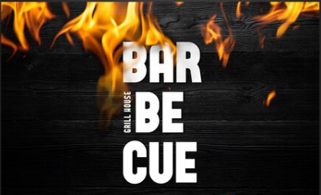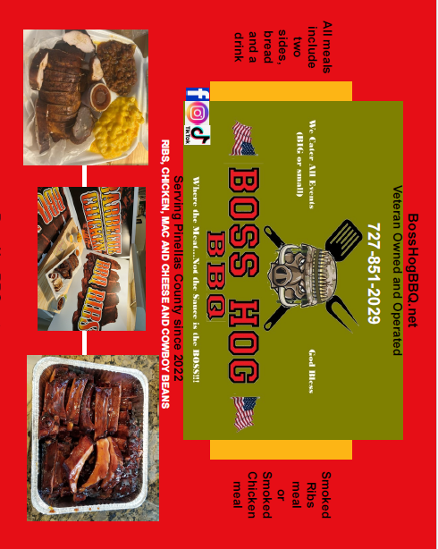 BOSS HOG BBQ is coming to
Hennessy Construction Services
on Thursday – March 27th @ 12pm

